Food Activity

There are 3 activities you have to do.

The first activity consists of counting the calories of each food listed and giving the total number of calories for each meal. You need to use the food sheet provided (the side that is labeled El rincón cultural). Be careful to note the portion sizes of the foods listed. They will affect the number of calories.

The second activity lists two people and their daily caloric requirements. You need to design a well-balanced set of meals for each person without going over the limit. List the calories for each food (per portion) that you put in their diet. You may use any of the foods listed on the food sheet but you will have to look up the caloric values for the foods on the second side.

The third activity requires you to pick a person you know (family member, friend, etc.) and identify the person’s age, weight and gender. The, using an online calorie counter, find out how many calories that person should consume on a daily basis. With that information you have to design a day’s worth of meals for that person. Once you have finished this activity, the person in your house who does the cooking needs to sign off on these 3 meals, saying that he/she agrees that this is a healthy set of meals. Feel free to have this person help you design the meals. For this activity only you need to write out the calorie counts in words, not numbers.

You need to cite your sources for any information you look up. You can place the citation(s) at the bottom of the second side of the activity sheet.

Lastly, 5 foods you use in the last activity have to be words that do not appear in the book or the first side of the food sheet (the side with the caloric values). They can be words that only show up on the second side of the sheet or from other sources (parents, etc.). Obviously, these foods have to be given in Spanish as well.

This activity is not optional and you are expected to turn it in upon your return from break. You will lose considerable points if you turn it in late. This activity will have the same value as a test.

(pie)

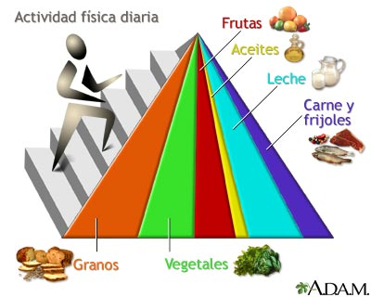
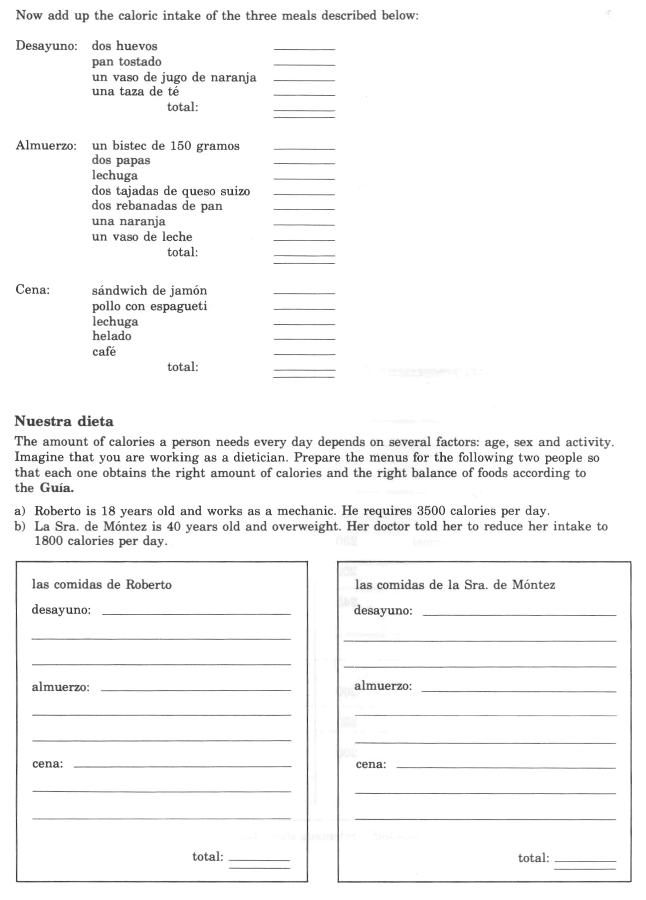
El desayuno:

Comida/porción Calorías

_______________________________ _______

_______________________________ _______

_______________________________ _______

_______________________________ _______

_______________________________ _______

El almuerzo:

_______________________________ _______

_______________________________ _______

_______________________________ _______

_______________________________ _______

_______________________________ _______

La cena:

_______________________________ _______

_______________________________ _______

_______________________________ _______

_______________________________ _______

_______________________________ _______

