Victims of Pinochet regime target Kissinger in courts
By Larry Rohter
New York Times News Service
March 29, 2002
SANTIAGO, Chile -- With a trial of Gen. Augusto Pinochet increasingly unlikely here, victims of the Chilean military's 17-year dictatorship are now pressing legal actions in Chilean and U.S. courts against Henry Kissinger and other Nixon administration officials who supported plots to overthrow Salvador Allende, the Socialist president, in the early 1970s.
In perhaps the most prominent of the cases, an investigating judge here has formally asked Kissinger, a former national security adviser and secretary of state, and Nathaniel Davis, the U.S. ambassador to Chile at the time, to respond to questions about the killing of an American citizen, Charles Horman, after the deadly military coup that brought Pinochet to power on Sept. 11, 1973.
Pinochet, now 85, ruled Chile until 1990. He was arrested in London in 1998 on a Spanish warrant charging him with human-rights violations. After 16 months in custody, Britain released Pinochet because of his declining health. Although he was arrested in Santiago in 2000, he was ruled mentally incompetent to stand trial.
The death of Horman, a filmmaker and journalist, was the subject of the 1982 movie "Missing." A lawsuit that his widow, Joyce, filed in the United States was withdrawn after she could not obtain access to relevant U.S. government documents. But the initiation of legal action in Chile against Pinochet and the declassification of some American documents led her to file a new suit in Chile 15 months ago.
Last fall, after gaining approval from Chile's Supreme Court, Judge Juan Guzman, who also is handling the Pinochet case, submitted 17 questions in the Horman case to U.S. authorities. An American Embassy official in Santiago confirmed that the document, known as a letter rogatory, has been received in Washington, but he said it has not been answered and that he did not know whether there would be a response.
"We're pressing the case in Chile because this is the first opportunity we have had to see if there is still some real evidence there," Joyce Horman said by telephone from New York. "But the letters rogatory seem to be in a paralyzed state."
William Rogers, Kissinger's lawyer, said in a letter that because the investigations in Chile and elsewhere related to Kissinger "in his capacity as secretary of state," the Department of State should respond to the issues that have been raised. He added that Kissinger is willing to "contribute what he can from his memory of those distant events" but did not say how or where that might occur.
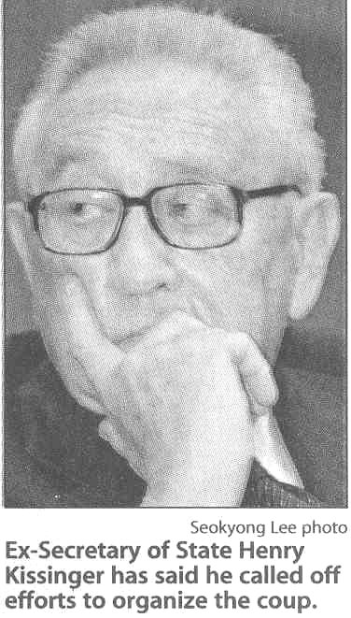

Relatives of Gen. Rene Schneider, commander of the Chilean armed forces when he was assassinated in October 1970 by other military officers, have taken a different approach. Alleging summary execution, assault and civil rights violations, they filed a $3 million lawsuit in Washington last fall against Kissinger, former CIA Director Richard Helms and other Nixon-era officials who, according to declassified U.S. documents, were involved in plotting a military coup to keep Allende from power.

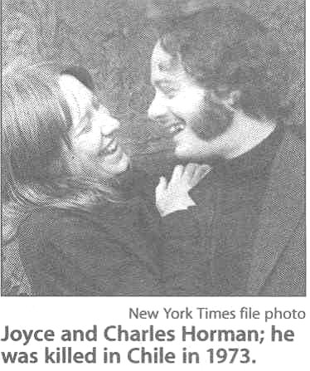

In his books, Kissinger has acknowledged that he initially followed Nixon's orders in September 1970 to organize a coup, but he also says he ordered the effort shut down a month later. However, the government documents indicate that the CIA continued to encourage a coup and also provided money to military officers who had been jailed for Schneider's death.
In another action, human-rights lawyers in Chile have filed a criminal complaint against Kissinger and other U.S. officials, accusing them of helping organize the covert regional program of political repression called Operation Condor.
As part of that plan, right-wing military dictatorships in Argentina, Bolivia, Brazil, Chile, Paraguay and Uruguay coordinated efforts throughout the 1970s to kidnap and kill hundreds of their exiled political opponents.
Argentina also has begun an investigation into U.S. support for and involvement in Operation Condor. A judge there, Rodolfo Cancioba Corral, has said he regards Kissinger as a potential "defendant or suspect." But lawyers say it is virtually impossible for a foreign court to compel former U.S. officials to answer a summons.
Copyright © 2002, Chicago Tribune

