Spanish 1

Travel Itinerary

Purpose: To research and create a travel itinerary to a Hispanic city. This will be done mostly in Spanish. You will create an itinerary on the sheet provided per instructions

Instructions:
- Research your city for tourist attractions, restaurants, hotels and background information
- Fill out the travel itinerary form per the rubric

Project Requirements: You must include:
- 3 tourist attractions, what day you will be visiting them and what you´re going to do there
- 3 restaurants, what day you will be visiting them and what you´re going to eat
- Information on airfare to this country
- Include price of hotel(or other) accommodations per night
- An overview of the city (background info, etc.) Place on back side of sheet. This is the only part that may be done in English
- Correct spelling and grammar usage throughout the brochure
A few things to remember …
- This counts as an exam grade.
- Use the time given in class. This is considered class participation and you will lose points for being off task
- Make sure you have ALL requirements
- If you turn this in late, you will be docked 20 points for each day

Checklist and Rubric
Max. Points
Correctly written dates & destination stated |  |  |  | 5
3 tourist attractions, what you’re going to do & the day |  |  |  | 25
3 different restaurants, what you’re going to eat & the day |  |  |  | 25
How much your hotel will cost for the # of days needed |  |  |  | 10
Airfare prices for # of people travelling |  |  |  | 10
Overview of city (give some background information) |  |  |  | 15
Correct spelling & grammar throughout |  |  |  | 10
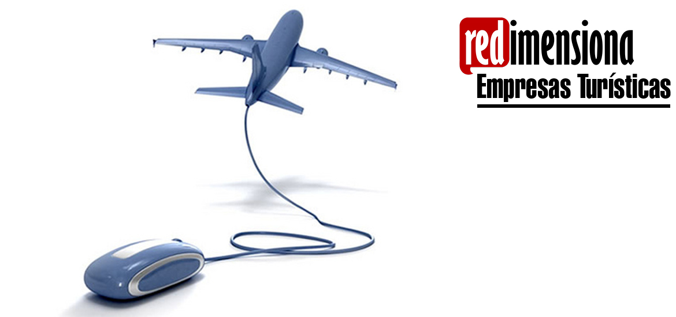

ITINERARIO DE VIAJE

Preparado para: |  |  | Con fechas:
Destino: |  |  | Número de personas:
Precio total de hotel/alojamiento: |  |  | Precio del pasaje aéreo de ida y vuelta (por persona):
Día | Lugar | Detalles de las actividades por desarrollar

